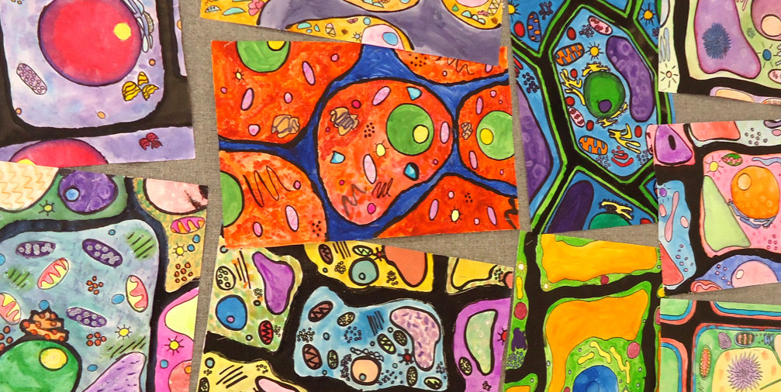

Record your THINK-PLAN-BRAINSTORM HERE…CLASSROOM RELEVANCE here…

* *Our Lives are in the Land:* centers on connections. Painting tells of how the plants are the teachers and provide support and wisdom to those who need it.
* Interconnectedness of all living things
* Technique/Formatting:
  + Background is black with very bright colours used to create image – intense contrast in colours; tradition to Metis artwork
  + Small dots to create some of the images; meant to mirror the look of beadwork – another traditional artform in Metis culture
  + The image takes up the entire canvas – conveys a feeling of being within the painting, as if you were in this actual environment
* Grade 5 Art Education
  + Big Ideas: *Engaging in creative expression and experiences expands people’s sense of identity and belonging* & *Artists experiment in a variety of ways to discover new possibilities and perspectives*
* Students will “Explore a range of cultures, and the relationships among cultures, societies, and the arts”
* Students will learn about the techniques, elements, strategies, used by the artist, the meaning/message behind the painting, how and where we can see the influence of Belcourt’s Metis heritage in her work
* This lesson allows for students to gain further insight to aspects of Indigenous culture and how this can be used to inspire Indigenous artists’ art – develop more knowledge on the varying differences between cultures and their art forms
* Explore the works and background of a Canadian artist that is an advocate for positive change in our country

ARTFUL TREASURES

OPENER - ENERGIZERS

SPOTLIGHT

TEMPLATE

**Indigenous Spotlight**

**Artist:** Christi Belcourt **Artwork Piece:** *Our Lives are in the Land*

MATERIALS/Gathering Information:

<http://christibelcourt.com/bio/>

Twitter: @christibelcourt

https://canadianart.ca/features/walking-softly-with-christi-belcourt/

THINK - PLAN - BRAINSTORM

Belcourt’s style is inspired by her Metis culture and this is clearly seen in her work. She has become very successful and I think students would benefit from learning as she is also a great role model. I would present her works to a grade 5 class.

FEATURE ARTIST:

Christi Belcourt,

Metis visual artist from Ontario, Canada

GO FURTHER…

Collage showcases works done by Belcourt and outlines areas of her background as well as the relevance her works has on curricular content.

EDUCATION 407

November 3, 2020

Sydney Borden